Benefit for Emily
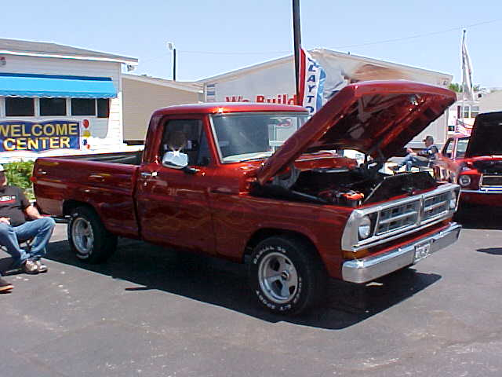
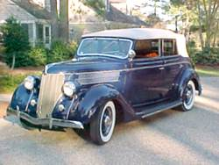
Come join the fun!
Please see her web page for more information.
http://getemilywalking.blogspot.com

Car Show

Sept. 16th. 2007- 2:00 PM to 6:00 PM

Rain date: Sept. 23rd 2007



5930 Overton Ridge Blvd.
Fort Worth, TX 76133

(817) 292-0078

$15.00 early Registration fee

$20.00 day of show,

Registration closes at 4:00 p.m.

Sponsors still needed - $50.00 with spot on t-shirt

Lot’s of fun for the whole family!

Live DJ – Doo Wopp Doug

Oldies Music – Original Vinyl

Name ____________________________________________________________________________

Address ____________________________City __________________ State _______ Zip _________

Phone ____________________ Email __________________________________

$15.00 Entry Fee – T-Shirts will be for sale for $5.00 for participants – Others will be $10.00 each.

Make checks out to Cheryl Wright & Mail to: Cheryl Wright – 549 Wright Lane – Weatherford, TX 76085

____ Street Rod ____ Special Interest

____ T-Bucket & Roadster ____ Motor Cycle

____ Pre 50’s Cars ____ Pre 60’s Truck

____ 50’s Cars ____ 60’s Trucks

____ 60’s Cars ____ 70’s Trucks

____ 70’s Cars ____ 80’s & Up Trucks

____ 80’s & Up Cars ____ Special Interest

____ Under Construction 70% & Above ____ Under Construction – 70% & Above

____ Young Gun ( 18 and below – will check) ____ Imports

____ Stereo Class

___ _______
Cheryl Wright 817-270-1007 - cheryl0614@gmail.com

Silent Auction! Concession Stand! Door Prizes!
50/50 POT!
“First and Second place awards in each class”
There will be one award for Best of show, Car, Truck, Motorcycle, Sponsors choice & Emily’s choice.

